**WIRELESS NETWORK SECURITY**

**ASSESSMENT**



**PONNADA TEJESWARARAO (TEAM LEADER)**

**RAPETI JAYA KUMAR**

**TANARI VARSHINI**

**TEKU SUKESH**

**VABALAREDDI DURGA**

* INTRODUCTION
* WHAT IS WIRELESS NETWORK SECURITY?
* EVALUATING THE SECURITY OF WIRELESS NETWORKS BY IDENTIFYING POTENTIAL VULNERABILITIES
* WEAK ENCRYPTION
* UNAUTHORIZED ACCESS POINTS
* PURPOSE OF WIRELESS NETWORK SECURITY
* WIRELESS NETWORK THREATS
* WIRELESS SECURITY AND VULNERABILITIES
* KEY STEPS OF WIRELESS NETWORK SECURITY
* COMMON WEAKNESS ENUMERATION CODE
* OPEN WEB SECURITY APPLICATION PROJECT(OWSAP)
* APPLICATIONS OF OWASP
* DETAILED REPORT OF WIRELESS NETWORK SECURITY

VULNERABILITY

**INTRODUCTION:**

Wireless network security refers to the protection of data and communication transmitted over wireless networks, such as Wi-Fi, Bluetooth, or cellular networks, from unauthorized access, interception, or manipulation. With the increasing use of wireless technologies, ensuring the security of these networks has become paramount, as they are susceptible to various vulnerabilities that can be exploited by malicious actors.

The primary objective of wireless network security is to safeguard the confidentiality, integrity, and availability of data and resources transmitted over the network. This is accomplished through the implementation of various security measures, protocols, and best practices to mitigate potential threats and risks.

One of the most critical concerns in wireless network security is unauthorized access. Hackers or intruders may attempt to gain unauthorized access to a wireless network to eavesdrop on communication, steal sensitive information, or launch attacks against connected devices. To combat this, authentication and encryption mechanisms are implemented to ensure that only authorized users can access the network and that data remains private and secure during transmission.

Common wireless network security protocols include WPA (Wi-Fi Protected Access) and WPA2, which offer stronger encryption and more robust security than the older WEP (Wired Equivalent Privacy) protocol. Additionally, advancements like WPA3 continue to improve security measures and address weaknesses found in earlier protocols.

Other essential aspects of wireless network security include intrusion detection and prevention systems (IDPS), which help identify and respond to potential threats in real-time. Network segmentation, virtual private networks (VPNs),

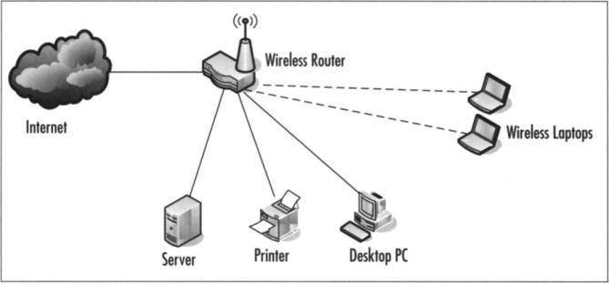

and firewalls are also employed to create secure zones and protect sensitive information from unauthorized access.

It is important for organizations and individuals alike to remain vigilant about wireless network security by regularly updating firmware and software, using strong and unique passwords, disabling unnecessary services, and staying informed about the latest security threats and vulnerabilities.

In summary, wireless network security is a crucial aspect of modern connectivity. By implementing robust security measures, organizations and individuals can ensure the safety and privacy of their data and communications in an increasingly wireless-dependent world.

**WHAT IS WIRELESS NETWORK SECURITY?**

Wireless network security refers to the protection of data, devices, and communication transmitted over wireless networks from unauthorized access, interception, and malicious activities. It encompasses a set of measures, protocols, and best practices aimed at safeguarding the confidentiality, integrity, and availability of information exchanged through wireless technologies.

Wireless networks, such as Wi-Fi, Bluetooth, and cellular networks, are inherently more vulnerable to security risks compared to wired networks. This is because wireless signals can extend beyond the physical boundaries of a premises, making it possible for attackers to intercept data from a distance, without having a direct physical connection to the network.

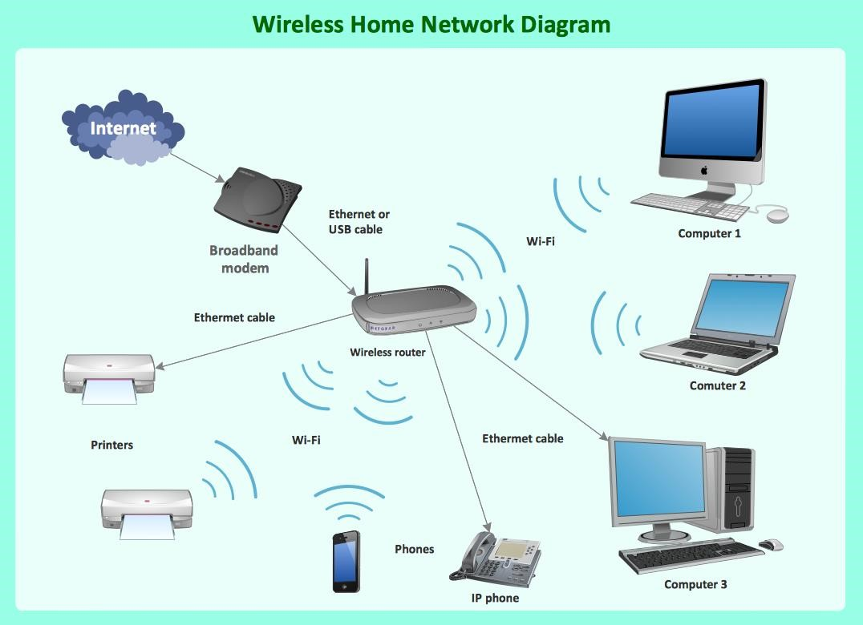

Key aspects of wireless network security include:

1. Authentication: Implementing strong authentication mechanisms to ensure that only authorized users can access the network. Common methods include passwords, WPA/WPA2/WPA3 (Wi-Fi Protected Access), and digital certificates.

1. Encryption: Encrypting data transmitted over the network to prevent eavesdropping and data interception. Encryption protocols like WPA2 and WPA3 use cryptographic techniques to secure the data being transmitted.

1. Access Control: Employing access control lists (ACLs) and network segmentation to limit access to specific resources and services. This helps minimize the impact of potential breaches and restricts unauthorized users from moving laterally within the network.

1. Firewalls: Deploying firewalls to monitor and control incoming and outgoing network traffic. Firewalls act as a barrier between the internal network and the external internet, preventing unauthorized access and blocking potentially malicious traffic.

1. Intrusion Detection and Prevention Systems (IDPS): Using IDPS to detect and respond to suspicious activities on the wireless network. These systems can identify potential security breaches, such as unauthorized devices attempting to connect or known attack patterns.

1. Physical Security: Protecting the physical components of the wireless network infrastructure, such as routers and access points, from tampering and unauthorized access.
2. Regular Updates and Patches: Keeping the firmware, software, and security protocols up to date to address known vulnerabilities and exploits.

1. User Awareness and Training: Educating users about potential security threats, best practices, and how to avoid falling victim to social engineering attacks or connecting to rogue wireless networks.

1. Rogue Access Point Detection: Using tools and techniques to identify and prevent the unauthorized deployment of rogue access points that can be used by attackers to launch man-in-the-middle attacks.

Wireless network security is an ongoing process that requires continuous monitoring, risk assessment, and adaptation to new threats and technologies. By implementing strong security measures, organizations and individuals can minimize the risk of data breaches, unauthorized access, and other wireless network-related security incidents.

**EVALUATING THE SECURITY OF WIRELESS NETWORKS BY IDENTIFYING POTENTIAL VULNERABILITIES:**

Evaluating the security of wireless networks is an essential step to identify potential vulnerabilities and ensure that the network is adequately protected against various threats. Here are some steps and considerations for conducting a security assessment of wireless networks:

* 1. Wireless Access Points (WAPs) Enumeration:

Identify all the wireless access points within the network. This includes both authorized and unauthorized access points, as rogue access points can pose serious security risks.

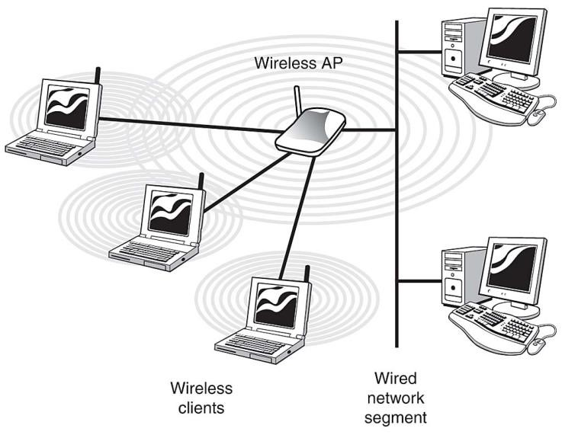

* 1. Wireless Security Protocols:

Check the security protocols being used for wireless communication. Ensure that WPA2 or WPA3 (the latest standard at the time of writing) with AES encryption is in use, as older protocols like WEP are vulnerable to attacks.

* 1. Encryption Strength:

Verify that strong encryption keys are being used. Weak or default encryption keys make the network susceptible to unauthorized access.



* 1. SSID Broadcasting:

Check if the Service Set Identifier (SSID) broadcasting is enabled. Disabling SSID broadcasting can add an extra layer of security.

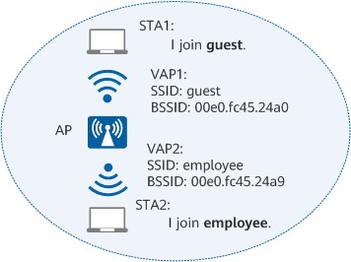

* 1. Password Policies:

Review the password policies for wireless networks. Ensure that strong and unique passwords are enforced for all users and access points.

* 1. Authentication Methods:

Evaluate the authentication methods used for accessing the wireless network. Implement strong authentication mechanisms like EAP-TLS or PEAP with server-side certificate validation.

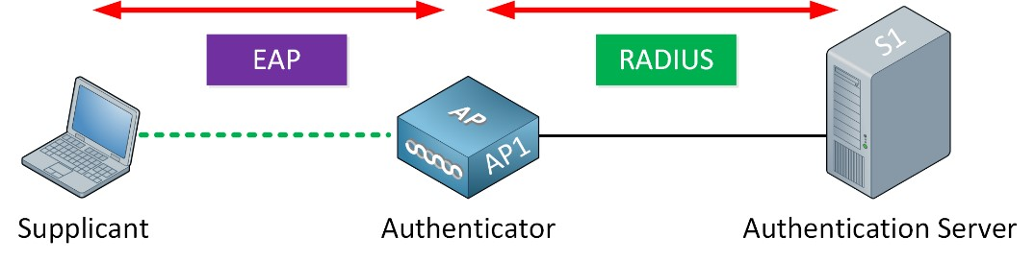

* 1. Guest Network Segregation:

If the network has a guest network, make sure it is properly segregated from the internal network to prevent unauthorized access to sensitive resources.

* 1. Physical Security:

Assess the physical security of wireless access points to prevent unauthorized tampering or access.

* 1. Wireless Intrusion Detection/Prevention Systems (WIDS/WIPS):

Consider deploying WIDS/WIPS to monitor the network for potential security breaches and automatically take actions to prevent attacks.

* 1. Firmware and Software Updates:

Ensure that all access points and network equipment have the latest firmware and software updates to mitigate known vulnerabilities.

* 1. Firewall and Network Segmentation:

Implement proper firewall rules and network segmentation to restrict unauthorized access and lateral movement within the network.

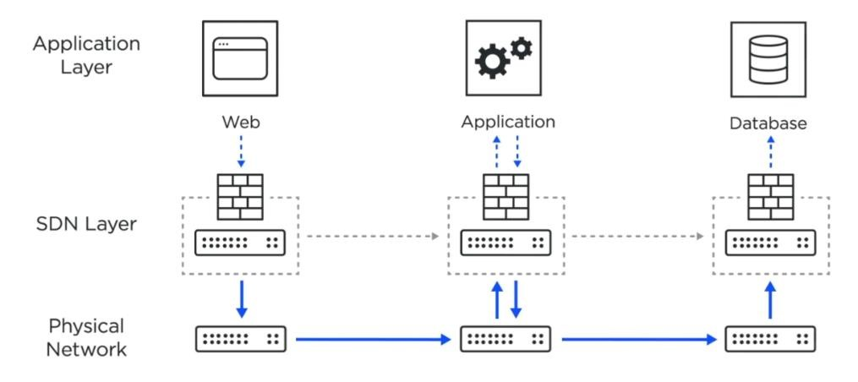

* 1. Penetration Testing:

Conduct regular penetration testing and security assessments to identify any overlooked vulnerabilities or misconfigurations.

* 1. Wireless Site Survey:

Perform a wireless site survey to identify potential signal leakage or areas with weak security coverage.

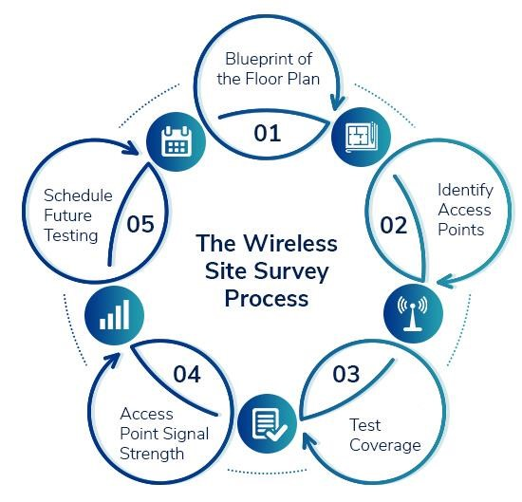

* 1. User Awareness and Training:

Educate users about secure wireless practices, such as avoiding public Wi-Fi, connecting only to trusted networks, and being cautious with their wireless devices.

* 1. Continuous Monitoring:

Implement continuous monitoring and logging of wireless network activities to detect and respond to security incidents prompt

1. **Weak Encryption:**

Encryption is a method used to protect sensitive information by converting it into unreadable code. Strong encryption ensures that even if data is intercepted or accessed by unauthorized parties, they cannot understand its contents without the appropriate decryption key. Weak encryption, on the other hand, can be easily cracked or bypassed, leaving the data vulnerable to unauthorized access and misuse.

Examples of weak encryption include outdated cryptographic algorithms, short encryption keys, or using default passwords or keys provided by hardware or software manufacturers. When encryption is weak, attackers can potentially gain access to sensitive data, leading to data breaches, identity theft, financial losses, and other security incidents.

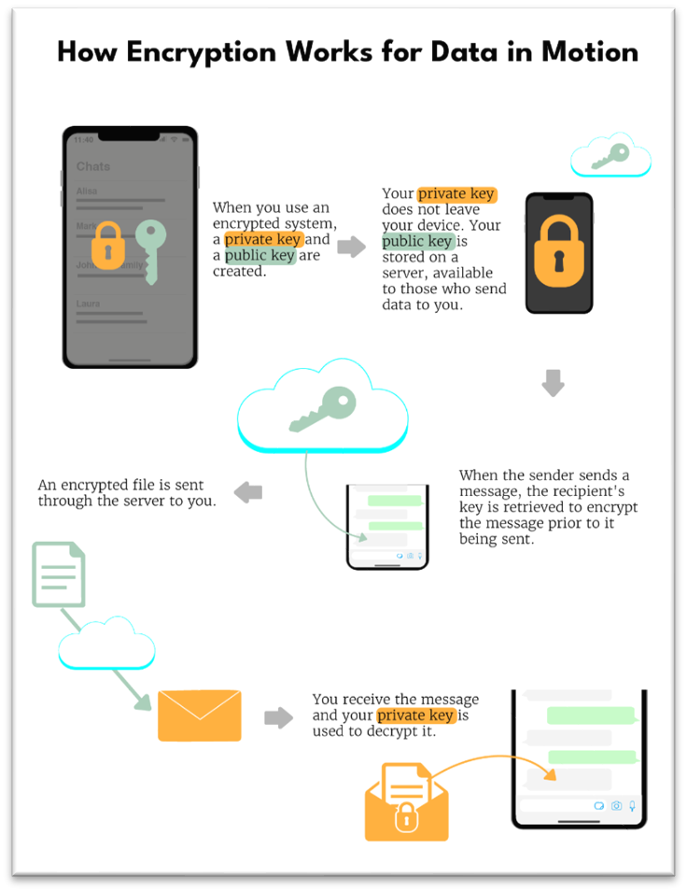

To mitigate weak encryption risks, it's crucial to use modern and strong encryption algorithms, keep software and firmware up to date, use long and complex encryption keys, and avoid using default passwords or keys. Regular security audits and assessments can help identify and fix weak encryption vulnerabilities in an organization's systems.

1. **Unauthorized Access Points:**

Unauthorized access points refer to any entry points into a network or system that are not explicitly authorized or managed by the organization's IT team. These access points can create security holes and allow attackers to bypass the organization's security measures, potentially gaining unauthorized access to sensitive data or systems.

Unauthorized access points can arise from various sources, including unsecured Wi-Fi networks, rogue devices connected to the network, and misconfigured network devices. For example, an employee might set up a wireless access point without the IT department's knowledge to make it more convenient for personal devices but inadvertently creates a potential security risk.

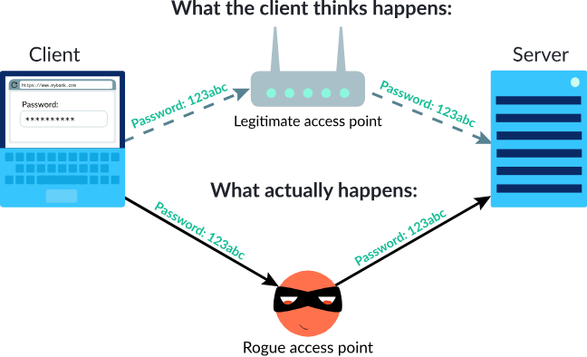

To address unauthorized access point risks, organizations should implement strong network access controls, regularly scan for rogue devices and unauthorized access points, enforce strong authentication methods (e.g., multifactor authentication), and educate employees about the risks associated with connecting unauthorized devices or creating ad-hoc networks.

Overall, addressing weak encryption and unauthorized access points requires a proactive and comprehensive approach to information security. Regular security assessments, employee training, and the implementation of best practices are essential to protect against these threats.

**PURPOSE OF WIRELESS NETWORK SECURITY:**

The purpose of wireless network security is to protect data, devices, and communication transmitted over wireless networks from various security threats and unauthorized access. It aims to ensure the confidentiality, integrity, and availability of information exchanged through wireless technologies such as Wi-Fi, Bluetooth, and cellular networks. The key purposes of wireless network security are as follows:

1. Protecting Data Privacy:

Wireless networks transmit data through radio waves, which can be intercepted by attackers if not properly secured. The primary purpose of wireless network security is to encrypt data during transmission, making it unintelligible to unauthorized individuals who may attempt to eavesdrop on sensitive information.



1. Preventing Unauthorized Access:

Wireless networks are accessible beyond the physical boundaries of a premises, making them susceptible to unauthorized access attempts. The purpose of security measures like authentication and access control is to ensure that only authorized users can connect to the network, reducing the risk of data breaches and unauthorized use of network resources.



1. Mitigating Man-in-the-Middle Attacks:

Wireless networks can be vulnerable to man-in-the-middle (MITM) attacks, where an attacker intercepts and potentially alters communication between two parties. Wireless network security aims to prevent MITM attacks by implementing encryption and secure authentication methods.

1. Securing Network Resources:

Wireless network security helps protect valuable network resources and sensitive information from unauthorized access and potential manipulation. By deploying access control mechanisms and intrusion detection systems, the network owner can monitor and control access to various resources and services.

1. Preventing Denial-of-Service (DoS) Attacks:

Wireless networks can be targeted with denial-of-service attacks, where attackers overload the network with excessive traffic, disrupting normal operations and causing service unavailability.

Wireless network security includes measures to detect and mitigate DoS attacks to ensure continuous and reliable network performance.

1. Safeguarding Against Rogue Access Points:

Rogue access points are unauthorized Wi-Fi access points set up by attackers to mimic legitimate networks and trick users into connecting to them. Wireless network security includes techniques to detect and prevent the use of rogue access points to minimize the risk of data exposure and unauthorized access.

1. Complying with Regulations and Standards:

Many industries and jurisdictions have specific regulations and standards related to wireless network security, especially when handling sensitive data. Ensuring compliance with these requirements is an essential purpose of wireless network security for organizations and businesses.

1. Protecting IoT and Smart Devices:

With the rise of the Internet of Things (IoT) and smart devices, wireless networks are increasingly interconnected. Securing these devices and their communication is critical to prevent potential security breaches that could have far-reaching consequences.

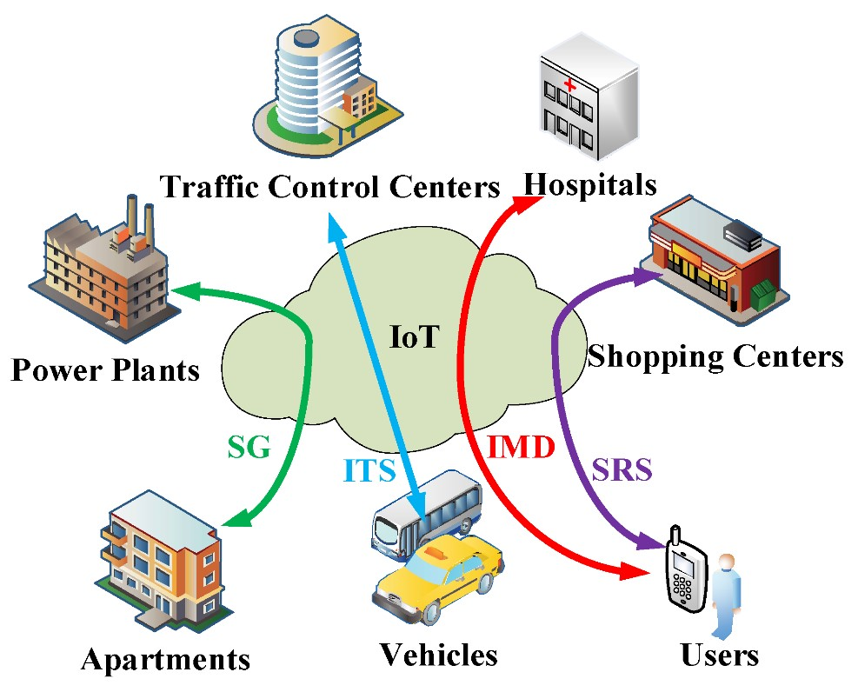

In conclusion, the purpose of wireless network security is to create a secure and trusted environment for wireless communication, safeguarding data, devices, and users from security threats and ensuring the reliable and confidential exchange of information over wireless networks.

**WIRELESS NETWORK THREATS:**

Wireless networks are susceptible to various security threats due to their inherent nature of transmitting data over radio waves, which can be intercepted and manipulated by attackers. Some of the common wireless network threats include:

1. Eavesdropping:

Attackers can intercept and listen in on wireless communication between devices, potentially capturing sensitive information, such as login credentials, financial data, or personal messages.

1. Man-in-the-Middle (MITM) Attacks:

In a MITM attack, an attacker positions themselves between two communicating devices and intercepts or alters the data exchanged between them. This allows the attacker to eavesdrop on the communication or even impersonate one of the parties involved.

1. Rogue Access Points:

Attackers can set up unauthorized access points that mimic legitimate ones to trick users into connecting. Once connected, the attacker can monitor and manipulate the traffic or launch further attacks.

1. Denial-of-Service (DoS) and Distributed Denial-of-Service (DDoS) Attacks:

These attacks flood a wireless network with excessive traffic, overwhelming its capacity and causing disruption or unavailability of services for legitimate users.

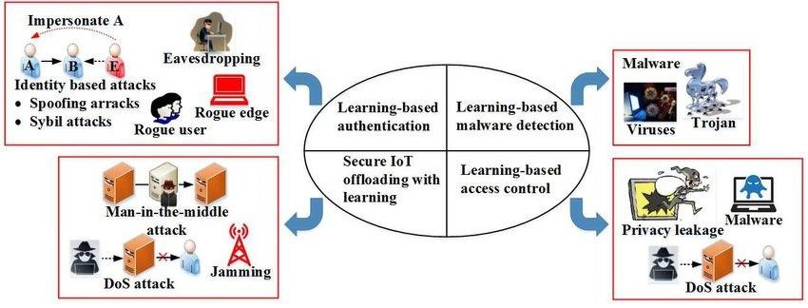

1. Authentication Attacks:

Brute-force attacks or credential guessing attempts may be made to exploit weak or default passwords on wireless networks and gain unauthorized access.

1. Encryption Cracking:

Weak encryption protocols or misconfigurations can be exploited to crack encryption keys, allowing attackers to decrypt and access the data transmitted over the network.

1. Evil Twin Attacks:

In an evil twin attack, an attacker creates a fake Wi-Fi network with a name similar to a legitimate one. Users unknowingly connect to the malicious network, allowing the attacker to intercept and manipulate their data.

1. Packet Sniffing:

Attackers may use packet sniffing tools to capture and analyse network traffic, revealing sensitive information, such as login credentials and unencrypted data.

1. Bluetooth Vulnerabilities:

Bluetooth-enabled devices can be vulnerable to various attacks, including bluejacking (sending unsolicited messages), bluesnarfing (stealing data), and bluebugging (taking control of a device).

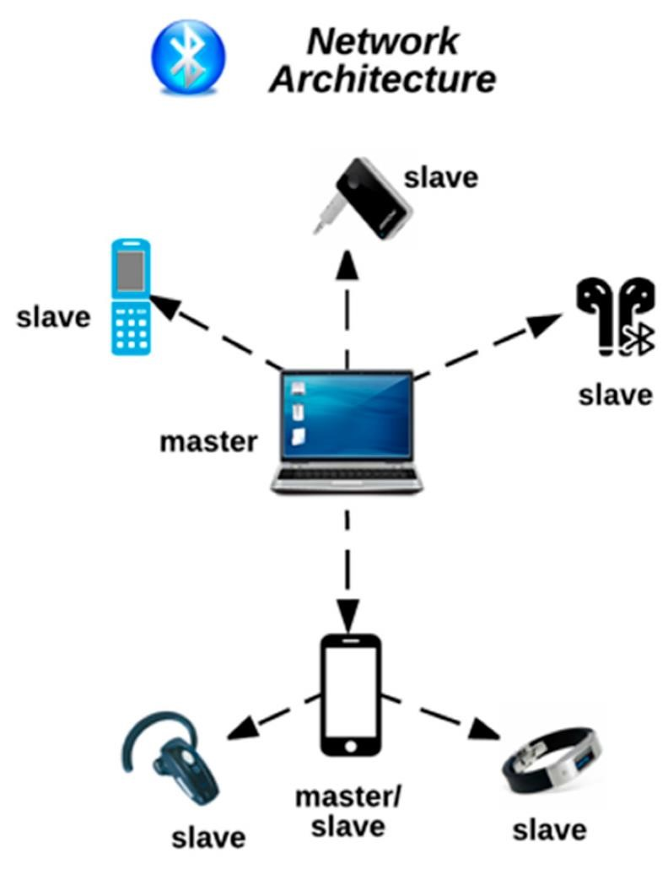

1. Zero-Day Exploits:

Unknown vulnerabilities or "zero-day" exploits in wireless networking devices can be exploited by attackers before the vendor releases a patch, giving them an advantage in launching attacks.

1. Physical Theft or Tampering:

Wireless networking devices, such as routers or access points, can be physically stolen or tampered with, allowing attackers to gain control of the network or collect sensitive data.

1. Cross-Site Scripting (XSS) Attacks:

Wireless networks that include web-based interfaces are vulnerable to XSS attacks, where attackers inject malicious scripts into web pages accessed by users, potentially compromising their devices.

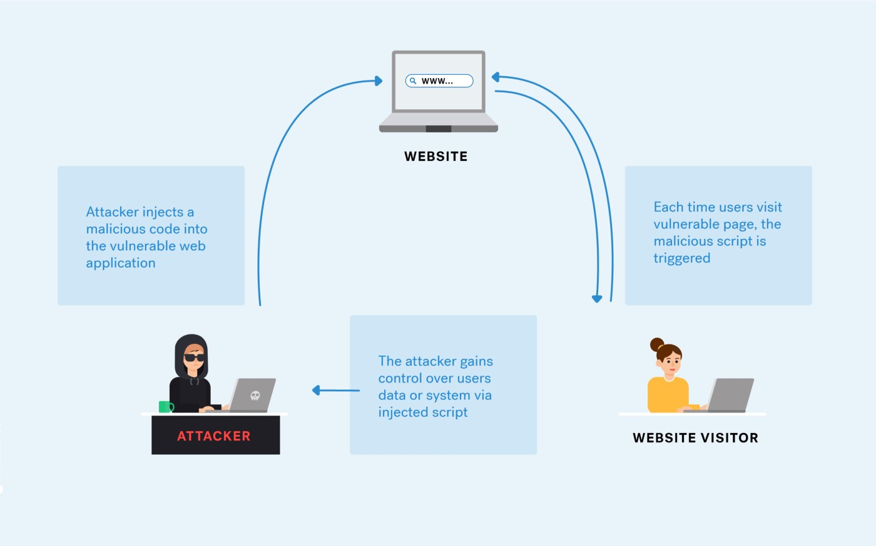

To protect against these threats, wireless network security measures, such as strong encryption, secure authentication protocols, regular software updates, and network monitoring, should be implemented. Additionally, user awareness and education about potential risks can help prevent many wireless networkrelated security incidents.

**WIRELESS SECURITY AND VULNERABILITIES:**

Wireless security is a critical aspect of protecting data and communication transmitted over wireless networks from potential vulnerabilities and security threats. While wireless technology provides convenience and flexibility, it also introduces specific vulnerabilities that attackers may exploit. Some of the common wireless security vulnerabilities include:

1. Weak Authentication and Encryption:

Using weak or default passwords for wireless networks and devices makes them susceptible to unauthorized access. Similarly, outdated or weak encryption protocols can be exploited by attackers to intercept and decode sensitive data.

1. Open Wi-Fi Networks:

Public or open Wi-Fi networks, such as those found in coffee shops or airports, lack proper security measures, making them easy targets for eavesdropping and man-in-the-middle attacks.



1. Rogue Access Points:

Unauthorized access points set up by attackers can mimic legitimate networks, leading users to unwittingly connect to them. This allows attackers to intercept and manipulate data or launch further attacks.

1. Evil Twin Attacks:

In evil twin attacks, attackers create fake Wi-Fi networks with names similar to legitimate ones to deceive users into connecting. Once connected, the attackers can intercept data and gain unauthorized access.

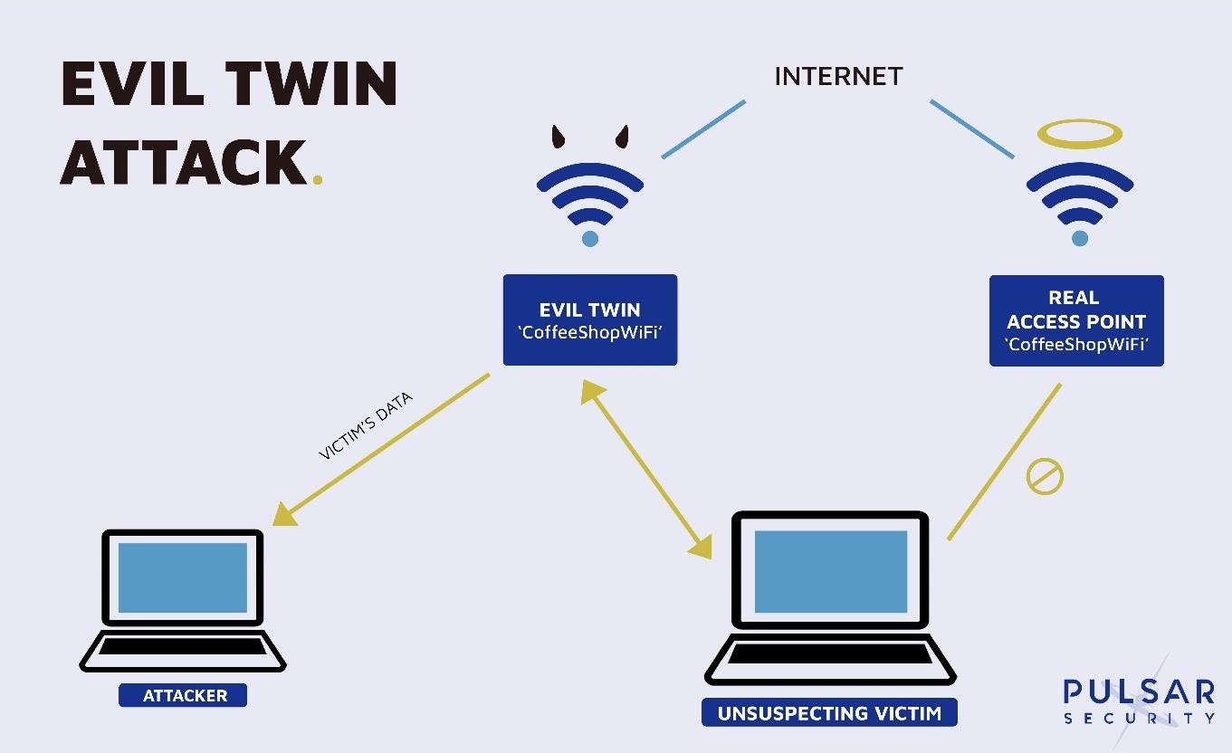

1. MAC Address Spoofing:

Attackers can spoof or forge MAC addresses to gain unauthorized access to a wireless network, bypassing MAC filtering security measures.

1. Packet Sniffing and Network Traffic Analysis:

Wireless signals can be intercepted and analysed to capture sensitive information, such as login credentials and unencrypted data, through packet sniffing techniques.

1. Bluetooth Vulnerabilities:

Bluetooth-enabled devices can be vulnerable to various attacks, including bluejacking, bluesnarfing, and bluebugging, which allow attackers to send unsolicited messages, steal data, or take control of devices.

1. Denial-of-Service (DoS) and Distributed Denial-of-Service (DDoS) Attacks:

Attackers may flood a wireless network with excessive traffic, overwhelming its capacity and causing service disruption or unavailability for legitimate users.

1. Zero-Day Exploits:

Unknown vulnerabilities or "zero-day" exploits in wireless networking devices can be exploited by attackers before vendors release patches, giving them an advantage in launching attacks.

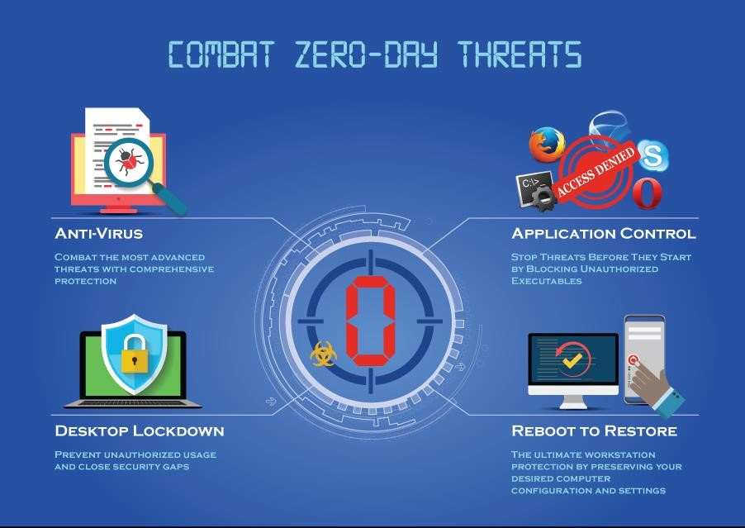

1. Physical Theft or Tampering:

Wireless networking devices, such as routers or access points, can be physically stolen or tampered with, allowing attackers to gain control of the network or collect sensitive data.

1. Interference and Jamming:

Attackers can use jamming devices to disrupt wireless signals, causing communication failure or network instability.

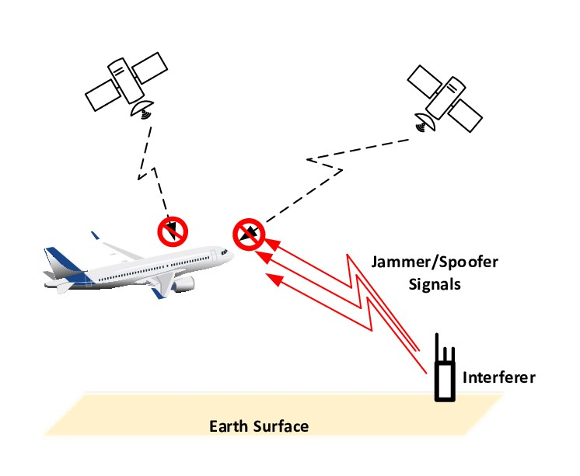

To address these vulnerabilities and enhance wireless security, it is crucial to implement robust security measures, such as using strong authentication methods, encrypting data with modern and secure protocols (e.g., WPA3), enabling network segmentation, and conducting regular security audits and updates. User education about wireless security risks and best practices is also essential to minimize the impact of potential.

**KEY STEPS OF WIRELESS NETWORK SECURITY:**

Here are the key steps and components typically involved in a wireless network security assessment project:

1. Scope Definition:

Clearly define the scope of the assessment, including the wireless network components to be tested, the locations, and the devices to be included.

1. Authorization and Legal Considerations:

Obtain proper authorization from the network owner or management to conduct the assessment. Ensure compliance with legal and ethical considerations, such as obtaining written consent and adhering to relevant regulations.

1. Reconnaissance:

Gather information about the wireless network, such as SSIDs (Service Set Identifiers), access points, encryption protocols used, wireless channels, and potential wireless clients.

1. Vulnerability Scanning:

Utilize specialized tools to conduct vulnerability scans on the wireless network infrastructure. These scans will help identify potential weaknesses, misconfigurations, and outdated software or firmware.

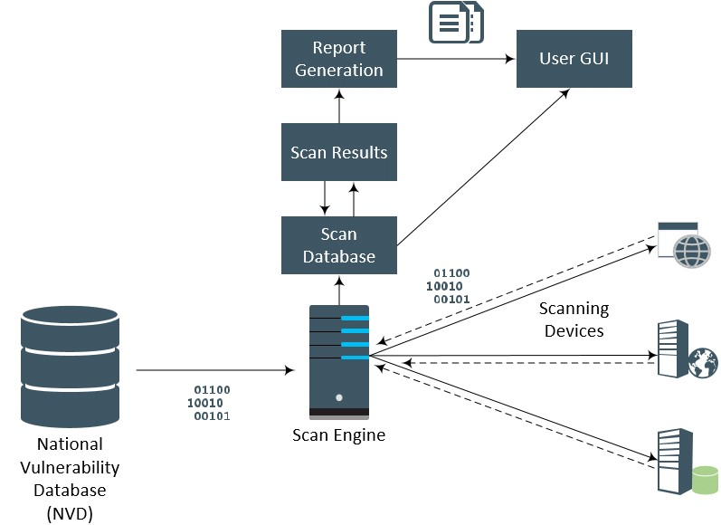

1. Wireless Traffic Analysis:

Monitor and analyse wireless network traffic to identify patterns, potential attacks, and suspicious activities.

1. Authentication and Encryption Assessment:

Evaluate the strength of authentication methods (e.g., WPA2, WPA3) and encryption protocols (e.g., AES) used in the wireless network.

1. Rogue Access Point Detection:

Identify any unauthorized access points that might have been set up within the network perimeter.

1. Password Cracking:

Attempt to crack weak or default passwords used on wireless devices and access points to demonstrate their vulnerability.



1. Social Engineering:

Conduct social engineering tests to assess the level of security awareness among employees or users who have access to the wireless network.

1. Physical Security Review:

Assess the physical security of wireless devices and access points to ensure they are protected from tampering or unauthorized access.

1. Policy and Configuration Review:

Review the existing security policies and configurations to ensure they align with industry best practices and security standards.

1. Report Generation:

Document the findings, including identified vulnerabilities, risks, and recommended mitigation measures. Provide clear, actionable recommendations for improving the wireless network's security.

1. Remediation Plan:

Work with the network owner or management to develop a prioritized plan for addressing the identified security issues and improving the overall wireless network security.

1. Post-Assessment Validation:

Conduct follow-up assessments to verify that the recommended security measures have been implemented and are effective in mitigating the identified risks.

**COMMON WEAKNESS ENUMERATION CODE:**

The Common Weakness Enumeration (CWE) is a community-developed list of common software and hardware weaknesses that serves as a standard taxonomy for describing and categorizing security vulnerabilities. Each CWE entry is identified by a unique ID, and it includes a description of the weakness, its potential consequences, and guidance on how to detect and mitigate it.

Below is an example of a simple code snippet that demonstrates a common weakness: "Improper Input Validation" (CWE-20). In this example, we have a function that takes user input and performs some action without properly validating or sanitizing the input, potentially leading to security vulnerabilities. **def process_user_input(user_input):**

**# CWE-20: Improper Input Validation**

**# The user_input is used directly without proper validation/sanitization.**

**# This can lead to security vulnerabilities like code injection attacks.**

**# For this example, let's assume this function processes user input in some way.**

**# In reality, you should have proper input validation and sanitization mechanisms**

**# depending on the context of your application.**

**# Vulnerable code: user_input is directly used in an SQL query.**

**# This could lead to SQL Injection vulnerability.**

**sql_query = f"SELECT * FROM users WHERE username='{user_input}';"**

**# Vulnerable code: user_input is used in an eval function.**

**# This could lead to code injection vulnerability.**

**result = eval(user_input)**

**# Some further processing...**

**return result # Example usage:**

**user_input = input("Enter your input: ")**

**output = process_user_input(user_input) print("Output:", output)**

Please note that this example intentionally showcases vulnerable code to demonstrate the weakness. In a real-world scenario, you should avoid using `eval` or directly concatenating user input into queries or commands. Instead, you should use proper input validation techniques, parameterized queries, or prepared statements, depending on the context and the programming language you are using.

Always follow secure coding practices to prevent common weaknesses and vulnerabilities in your software applications. CWE provides a comprehensive list of common weaknesses, and it's beneficial to review them and apply appropriate mitigations for each specific scenario in your code.

**OPEN WEB APPLICATION SECURITY PROJECT (OWASP):**

The Open Web Application Security Project (OWASP) is a nonprofit organization focused on improving the security of software applications, especially web applications. OWASP provides resources, tools, and documentation to help organizations and developers build secure software and protect against security threats. It operates as a community-driven project, bringing together security professionals, developers, and researchers to collaborate and share knowledge.

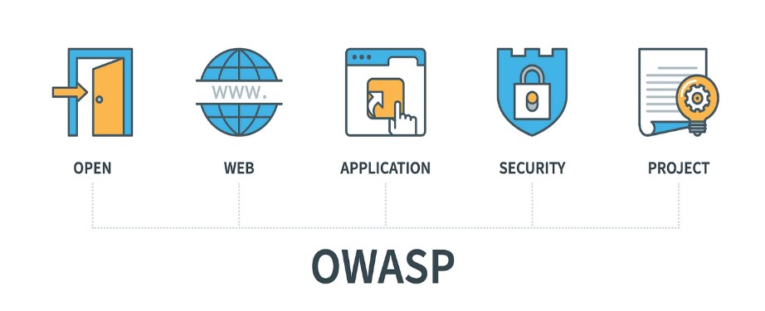

**APPLCATIONS OF OWASP:**

1. OWASP ZAP (Zed Attack Proxy):

An open-source web application security scanner used for finding vulnerabilities in web applications. It can be used for both manual and automated security testing.



1. OWASP Web Security Testing Guide:

A comprehensive guide that provides techniques, methods, and tools for testing the security of web applications.

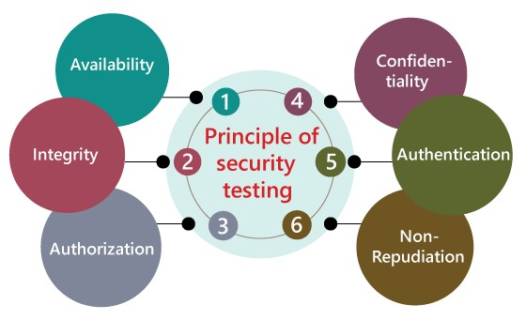

3. OWASP ModSecurity Core Rule Set (CRS):

A set of rules for the ModSecurity web application firewall (WAF) module. It helps protect web applications from various attacks and security vulnerabilities.



4. OWASP Dependency-Check:

A utility used to identify project dependencies with known, published vulnerabilities.

5. OWASP Application Security Verification Standard (ASVS):

A standard for ensuring that the application satisfies security requirements and mitigates security risks.

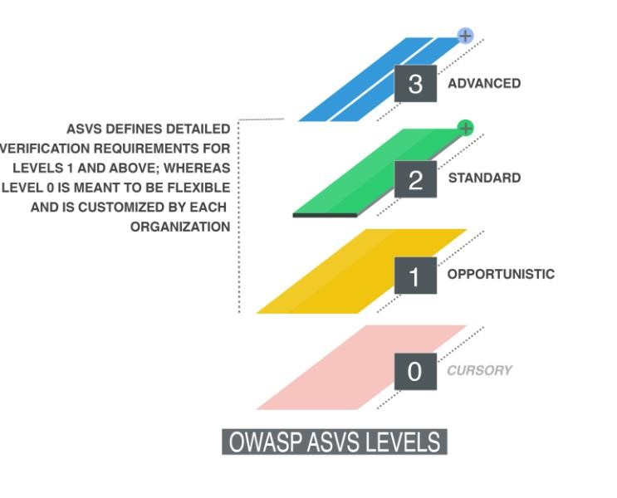

1. OWASP Juice Shop:

A deliberately vulnerable web application used for security training and practicing hacking techniques safely.

1. OWASP Defectdojo:

An open-source application vulnerability management tool that streamlines and automates security testing results.

1. OWASP Security Knowledge Framework:

A tool that helps developers learn about secure coding practices and provides guidance on secure code development.

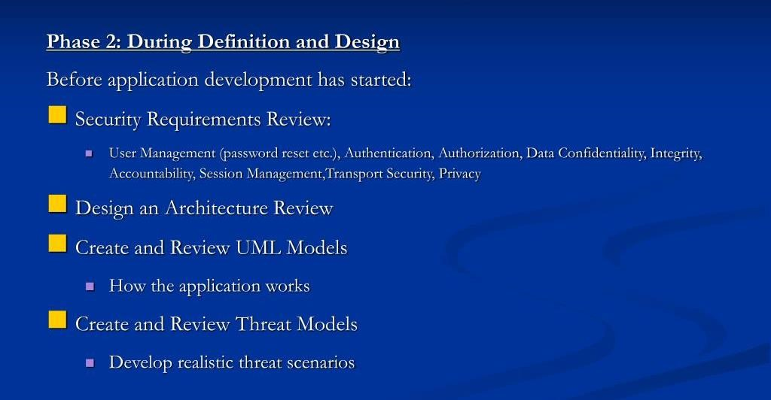

OWASP's main objectives include:

1. Awareness: Raise awareness about web application security risks and best practices among developers, businesses, and users.

1. Education: Provide educational materials, guidelines, and resources to help developers and organizations build secure applications.

1. Tools and Standards: Develop and maintain tools, standards, and best practices related to web application security.

1. Community: Foster a collaborative and inclusive community where security professionals can share knowledge and experiences.

1. Research: Promote research on web application security and publish the findings to enhance understanding and defence against threats.

One of OWASP's most well-known projects is the "OWASP Top Ten" list, which identifies and describes the ten most critical web application security risks. The list is regularly updated to reflect emerging threats and vulnerabilities.

Additionally, OWASP hosts numerous other projects, including security testing tools, documentation on secure coding practices, and security resources for various programming languages and frameworks.

The OWASP community also conducts global and regional events, conferences, and training sessions to promote web application security awareness and education.

**Title: Wireless Network Security Vulnerability Report**

**Executive Summary**:

This report aims to identify and describe various vulnerabilities present in wireless network environments, along with detailed instructions on how to reproduce each vulnerability. Understanding these vulnerabilities and their replication steps is crucial for developers, as it empowers them to comprehend the specific actions required to address and fix each vulnerability effectively. By proactively remediating these issues, developers can enhance the security posture of wireless networks, safeguarding sensitive data and ensuring the integrity of wireless communications.

1. **Introduction:**

Wireless networks play a crucial role in modern communication, but they are susceptible to various security vulnerabilities that can be exploited by malicious actors. This report focuses on key vulnerabilities related to weak encryption, misconfigurations, and unauthorized access points. It provides step-by-step instructions to reproduce each vulnerability, enabling developers to comprehend the root causes and implement appropriate fixes.

1. **Methodology:**

The vulnerabilities were identified using a combination of manual assessments and automated security tools, including OWASP and CWE. The wireless network infrastructure was tested in controlled environments to ensure the accuracy of the findings. Each vulnerability was categorized and assigned a risk rating based on its potential impact and likelihood of exploitation.

1. **Vulnerability** 1: Weak Encryption Protocol

Description:

This vulnerability involves the use of weak or outdated encryption protocols in the wireless network. Attackers can exploit this weakness to intercept and decrypt sensitive data transmitted over the network.

**Reproduction Steps:**

1. Access the wireless network using a device capable of capturing network traffic (e.g., Wireshark).
2. Capture packets transmitted over the network during a data exchange.
3. Analyze the captured packets to identify the encryption protocol used.
4. Utilize publicly available tools and resources to attempt decryption on the captured data.

**Impact:**

Attackers can gain unauthorized access to sensitive data, compromising the confidentiality and integrity of communications.

**Fix:**

Developers should ensure the use of strong encryption protocols (e.g., WPA2, WPA3) and disable outdated protocols (e.g., WEP). Regularly update network devices to apply security patches and maintain the latest encryption standards.

**4. Vulnerability** 2: Misconfigured Access Point

Description:

Misconfigurations in access points can lead to potential security breaches. This vulnerability arises when access points have default or weak passwords, incorrect security settings, or unnecessary services enabled.

**Reproduction Steps:**

1. Identify the wireless access point model and vendor.
2. Research the default settings and credentials for the identified model.
3. Attempt to access the administrative interface using default or easily guessable credentials.
4. Analyze the security settings and services enabled on the access point.

**Impact:**

Attackers can gain unauthorized access to the access point, control network settings, and potentially launch further attacks on connected devices.

**Fix:**

Developers should change default credentials for access points, employ strong passwords, and disable unnecessary services. Regularly audit and review access point configurations to ensure compliance with security best practices.

1. **Vulnerability** 3: Unauthorized Access Point (Rogue AP)

Description:

This vulnerability involves the presence of unauthorized or rogue access points within the network. Rogue APs can act as entry points for attackers to intercept network traffic and compromise security.

**Reproduction Steps:**

1. Perform a wireless network scan using tools like Kismet or Aircrack-ng.
2. Identify wireless networks and access points that are not part of the authorized infrastructure.
3. Analyze signal strength and location to pinpoint rogue access points.

**Impact:**

Rogue access points can enable attackers to launch man-in-the-middle attacks, capture sensitive data, and potentially compromise the entire network.

**Fix:**

Developers should regularly perform wireless network scans to detect unauthorized access points. Implement strong access control mechanisms to prevent unauthorized devices from connecting to the network.

**6. Conclusion:**

This report highlights critical vulnerabilities in wireless networks and provides detailed instructions to reproduce each issue. Understanding the steps required to replicate these vulnerabilities empowers developers to implement appropriate fixes and enhance the overall security of wireless networks. By addressing these vulnerabilities proactively, developers can safeguard sensitive data and protect the integrity of wireless communications, creating a more resilient network infrastructure.